Submission Report

# Gym and fitness website

Subject**:**

**Internet programming laboratory**

Course Code: CSE326

|  |  |  |  |
| --- | --- | --- | --- |
| Sr. No. | Registration No | Name of Students | Roll No |
| 1 | 11906767 | Syed Hassan Ul Haq | 04 |
| 2 | 11906788 | Sonu Singh | 05 |
| 3 | 11906790 | Vishwajeet Kumar | 06 |

Submitted to **Manu Bali**

**Lovely Professional University, Jalandhar, Punjab**

|  |  |
| --- | --- |
| Signature |  |

Section: K19AW Group: 1

About Website

Description:

This website is an Online Fitness club and Gym website. It follows a globally proven fitness training module with state-of-the-art infrastructure and delivery methodology and continuous up gradation through training programs. With certified trainers and nutritional counseling, provides a comprehensive approach to the health and well-being of its member. Whether your goal is to burn fat, tone or add muscle, build strength, increase flexibility or improve your cardiovascular health, only **Fitme.com** has the atmosphere and experience you need.

LANGUAGES USED IN WEBPAGES

|  |  |
| --- | --- |
| HTML | HTML has been used to Make the structure of the Webpage in Frontend Side. |
| CSS | CSS has been used to style the webpages and introduce features like responsive webpages and Modern Webpage Layout. |
| JavaScript | An object-oriented computer programming language used to create interactive effects within web pages. |

WEBSITE DESIGN, LAYOUT, MODULES & FLOW OF CONTROL

Interface:

Interface is traditional User – Webpage system. Everything is accessible only when the user is created and authenticated. User can enjoy smooth flow over all the pages available on the website from any of the page(s).

Modules:

1. **Homepage:**

This is the very first page of **Fitme.com**. It contains four different elements:

1. **Header:**

Header contains logo of the site (on left) and links to other sections of the webpage (on right).

1. **Cover Image:**

This division contains the cover image of our site (on left). The image perfectly suits name of our website.

1. **Login and Register button:**

Aside of the cover image, this division contains two buttons i.e. **Login** and **Register**. Clicking on the button takes you to the form.

1. **About us:**

Bottom of the cover page this division contains description of our website. Answers all **Wh.** questions that a first time visitor of our site can have for us.

1. **Feedback:**

Aside of the **About us** section, this division contains feedback button. Clicking on this a first time user can give the feedback about the homepage of our website.

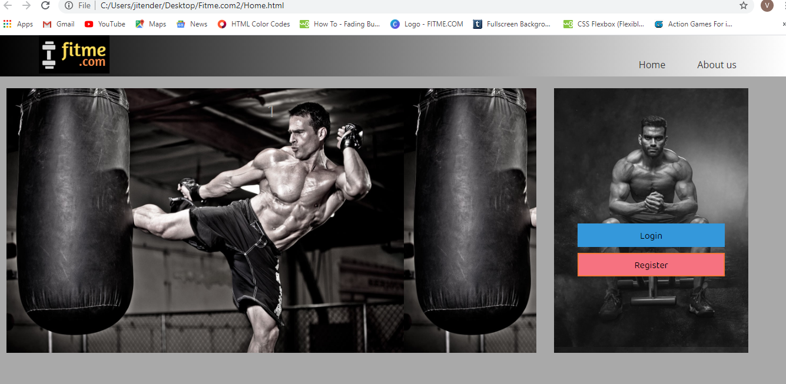

Homepage: Fitme.com

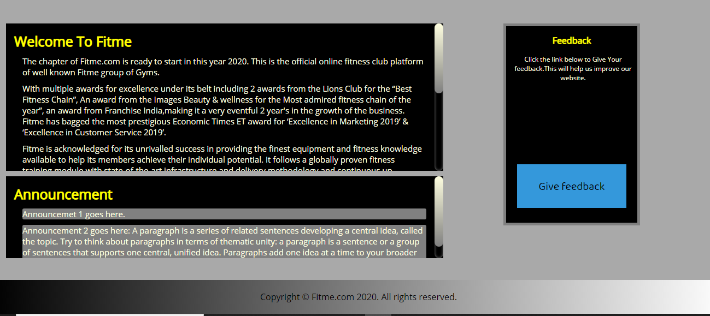

Homepage: Fitme.com

1. **Login & Register:**

This page contains two forms merged in a single division. This is very interactive and user friendly as whether one wants to register or login. Both can be done at same place. JavaScript made it awesome. Once you register you can login and can access the content that is available only to authenticated users.

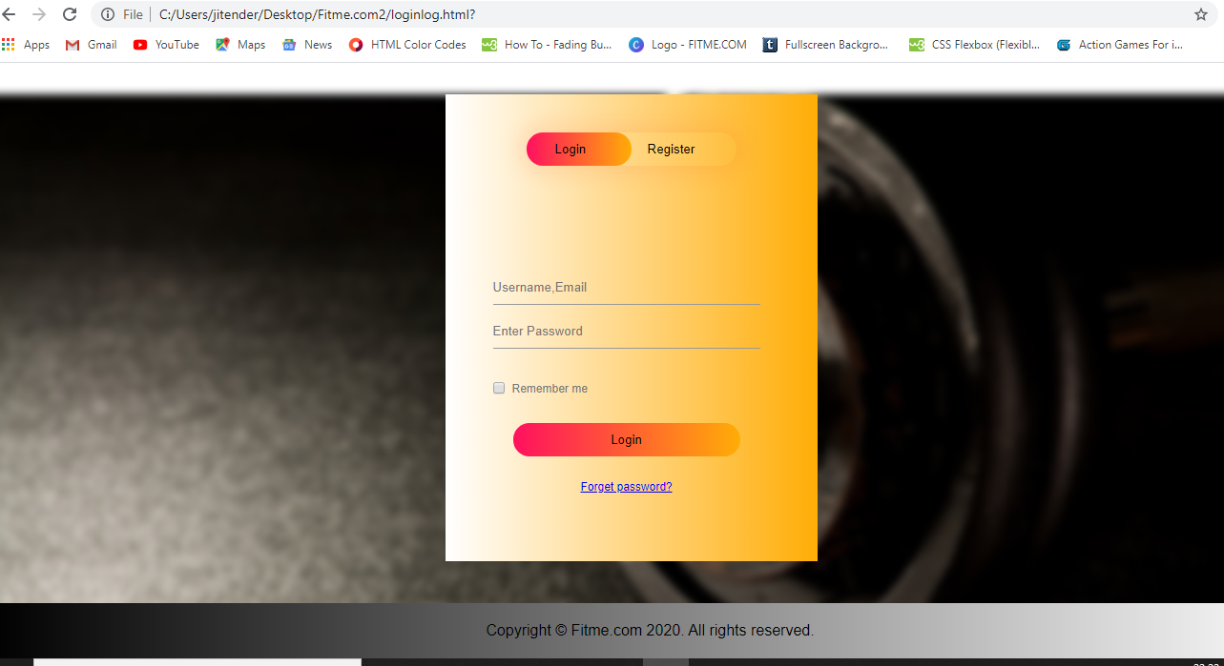

Login and Register

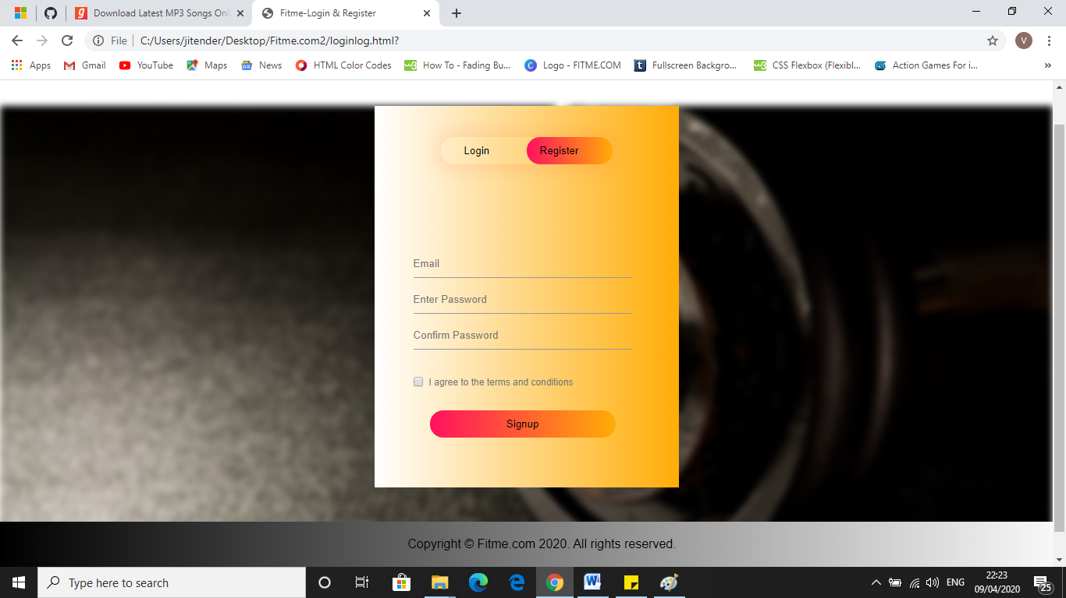

Login and Register

1. **Sections:**

Once logged in, user can access these sections:

1. **Nutrition:**

This section contains the facts related to various food items and diet suggestions for different users.

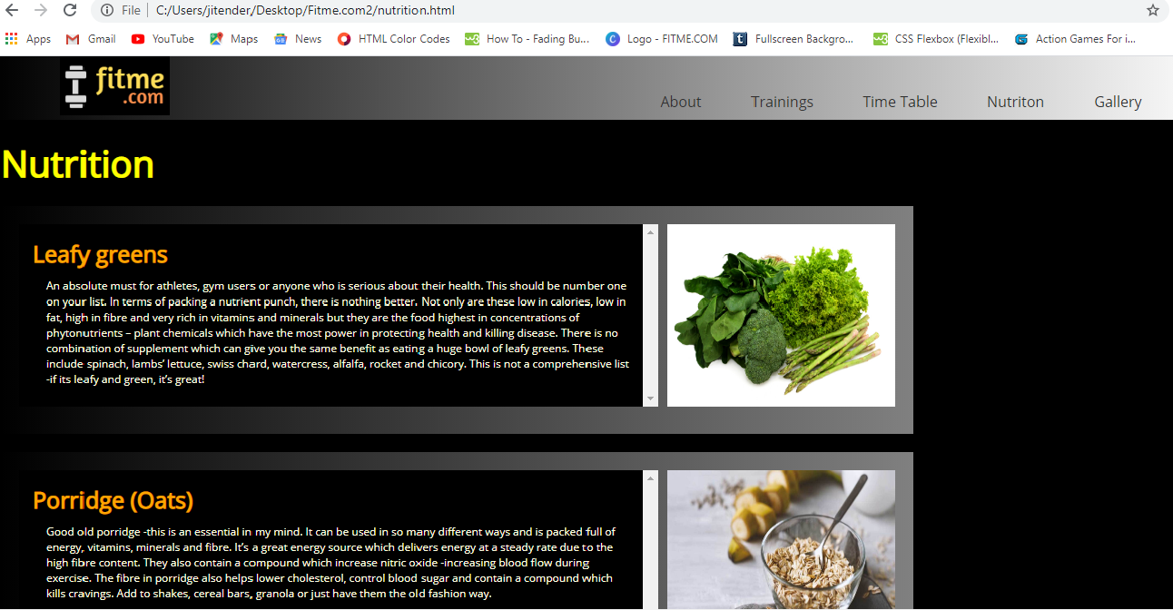

1. **Trainings:**

This section contains various trainings a user can have under our Gym program.

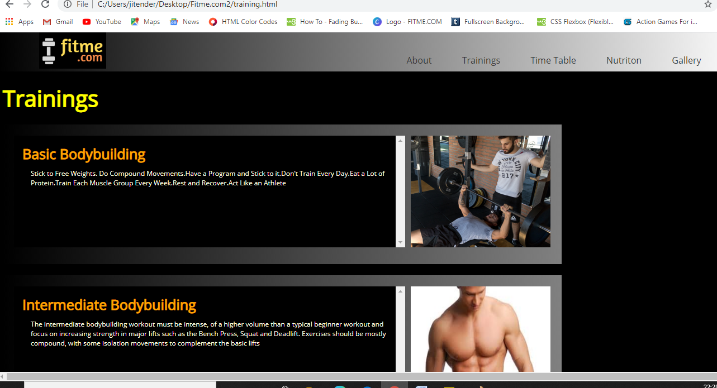

1. **Time-Table:**

This section contains different time-tables user can have for different training courses and fitness program.

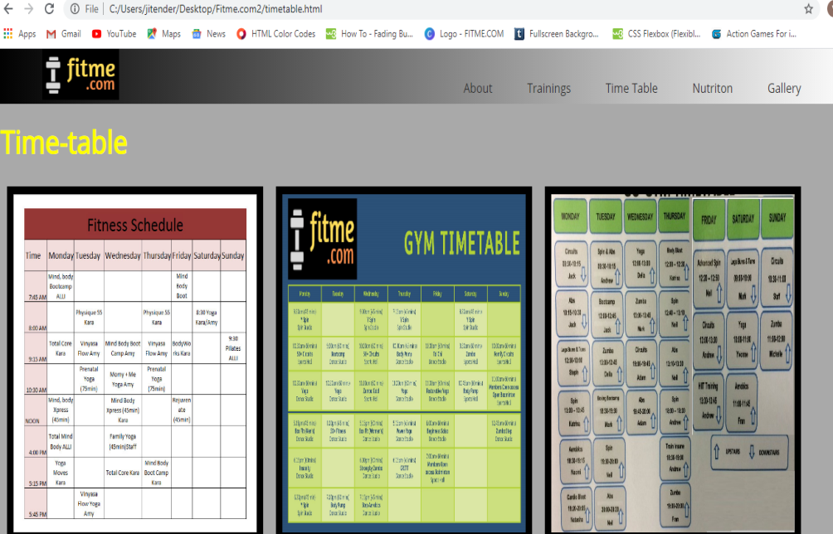

1. **Gallery:**

This section contains the photos of events, exercises, organizers, and trainers etc. that are working, related and linked with us.

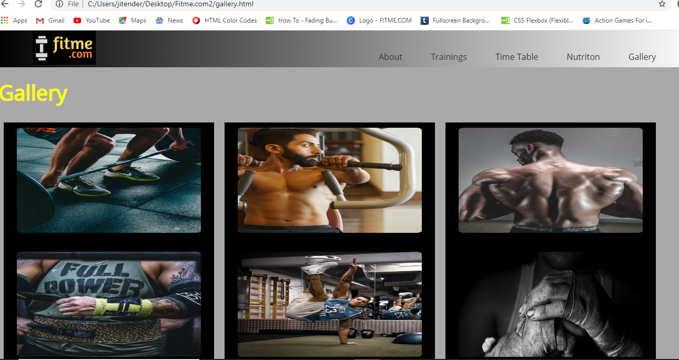

1. **Feedback:**

This section contains the feedback form for our users. They can give us their feedback about our services & website.

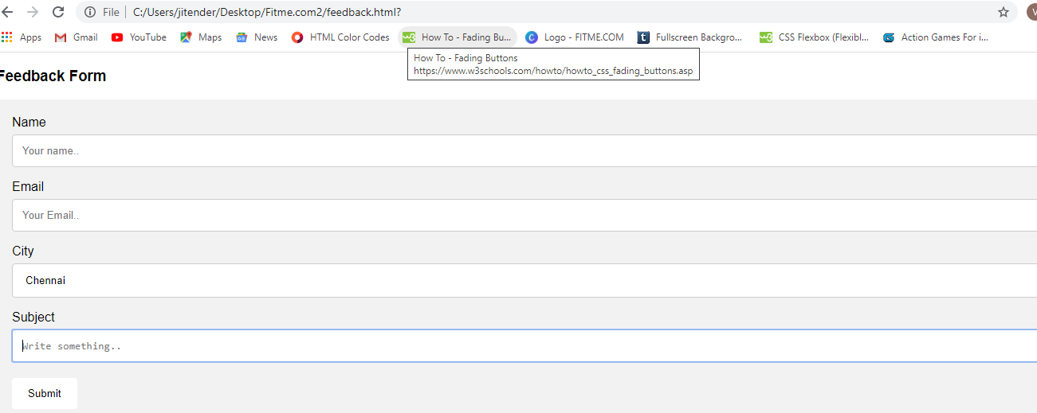

1. **Color scheme:**

We have used the traditional **Black-Grey** color scheme for our website. Buttons are having variants of Blue & Sky-blue, Orange and Red, White and orange, White & Green, Grey & white etc.

1. **Effects/Special Tags used:**

**Hover** effect is used for attractive buttons and links.

**Linear-gradient()** is used for creating attractive colored divisions.

**Marquee** is used to float the text.

**Transition** is used on buttons.

Attractive and colorful scroll bars have been used. Created bu using **webkit-scrollbar** functions.

**Resize**, **border-radius**, are used.

**Overflow** is used.

**Flex-container** is used.

**User defined classes** using CSSare used and reused throughout the code.

1. **Fonts – Family and style:**

Light colors on black background and dark colors on light background have been used.

Fonts: **Open Sans**, **Baloo Chettan 2**, **Arial**, **Halvetica** , **Sans serif**.

ABOUTTHEDEVELOPERS

**Vishwajeet Kumar:**

Founder, **Fitme.com.**  Backbone behind the formation of the website. Worked on the design, interface, functioning and color scheme of the website.

**Sonu Singh:**

Programmer. Worked on developing webpages of the website. Writing the content wherever needed. Worked on some sections of CSS.

Webpages developed: Nutrition section & feedback section.

**Syed Hassan Ul Haq:**

Programmer. Worked on developing webpages of the website. Writing the content wherever needed. Worked on some sections of CSS.

Webpages developed: About us section & feedback section.